RCM Web Services

RCM provides us multiple services. We can consume these services to add case, alert, case alert association, etc.

# Connect To RCM from Java

RCM Connection details are stored in system_configuration table. Following query can be used to fetch the details.

*SELECT rcm_server_url, rcm_admin_user, rcm_admin_password FROM system_configuration;*

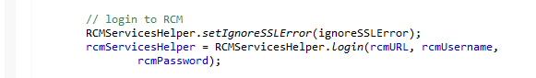

Login method of RCMServicesHelper uses authService to perform authentication.

# Get Endpoints for Service

To consume a service, endpoint needs to be provided. Endpoint for Authentication Service, Cases Service and Alerts Service are as shown in screenshot below.

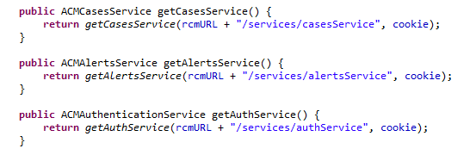

# Get Cases Service

Once we have endpoint for cases service, we can get object of cases service as follows

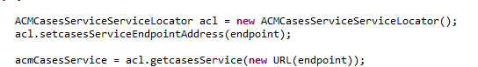

# Get Alerts Service

Once we have endpoint for alerts service, we can get object of alerts service as follows



# Get Authentication Service

Once we have endpoint for authentication service, we can get object of authentication service as follows



# Authentication Service: login Method

Once we have object of authentication service, we can use login method of the service to login to RCM.



# Authentication Service: logout Method

Once we have object of authentication service, we can use logout method of the service to logout of RCM.



# Cases Service: addCases Method

Once we have object of cases service, we can use addCases method of the service to add a case. addCases method accepts array of “Caze” objects.

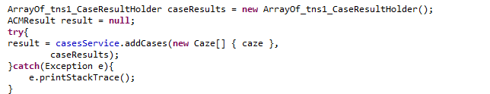

Create Caze Object

Caze Object is part of acmws.jar. We can create and populate Caze object as follows.



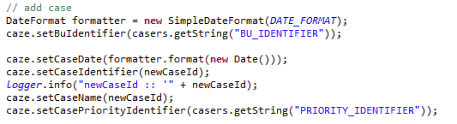  




Set Case Attributes

Case attributes can be set for the case to be added as shown below.

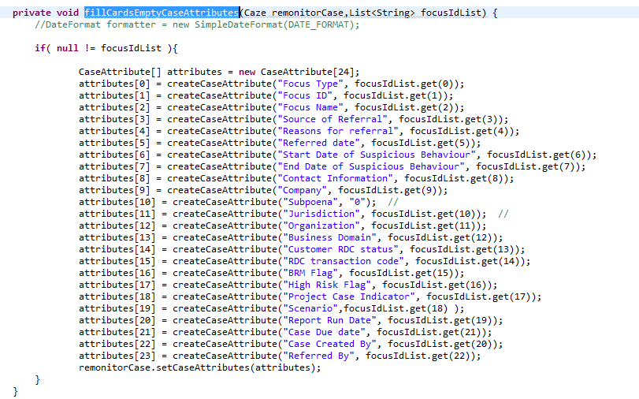

# Alerts Service: addAlerts Method

Once we have object of alerts service, we can use addAlerts method of the service to add an alert. addAlerts method accepts array of “Alert” objects.

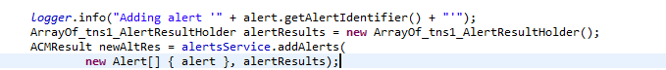

Create Alert Object

Alert Object is part of acmws.jar. We can create and populate Alert object as follows.

